16.11.2006
Name :
Number :
CSE221 DIGITAL LOGIC FUNDAMENTALS
MIDTERM – I

( 12 ) | 1 | Convert the following numbers from the given base to the other three bases indicated  - (10111101,0101) ₂ =( ? ) ₈ = ( ? ) ₁₀  - (25,615)₁₀ = ( ? ) ₁₆ = ( ? ) ₂
( 16 ) | 2 | Perform the following arithmetic operation for binary numbers 11100111 and 00001010 without converting to decimal. The binary numbers listed have a sign in the left most position and, if negative, are in 2’s complement form. Find decimal equivalents of the results.  - Multiplication ( 10 bits result)  - Division ( 4 bits result)
( 20 ) | 3 | Using a Karnaugh map, convert the following expression into the minimum Product of Sum and Sum of Product. Implement it using NAND gates only.
( 10 ) | 4 | Simplify the given expression by using only Boolean Algebra
( 10 ) | 5 | Convert the decimal numbers 676 and 377 to BCD and add.
( 20 ) | 6 | Design a logic circuit which calculates (Q) multiplication of two numbers (A and B) with two bits  (A₁A₀) x (B₁B₀ )= Q₃Q₂Q₁Q₀
(12) | 7 | Determine the decimal values of the two signed binary numbers 01010011 and 11101110 in the following systems:  - Signed-magnitude system  - 1’s complement system  - 2’s complement system
( 10 ) | 8 | Draw the output waveforms ( G₁,G₂,G₃,G₄, X) for the following logic diagram.  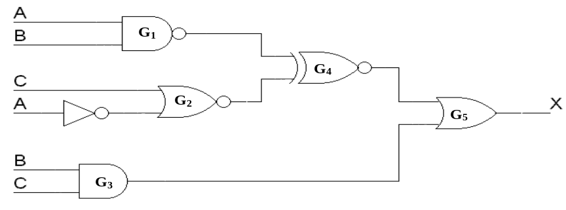

A

B

C

G
1

G
2

G
3

G
4

X

